**Pre-Requisite on All the ceph nodes**

**Step 0: Configure Proxy**

#  vim /etc/apt/apt.conf.d/proxy.conf

Acquire::http::proxy "http://jpe3proxy.jaws.jio.com:8080";

Acquire::https::proxy "http://jpe3proxy.jaws.jio.com:8080";

# vim /etc/apt/apt.conf.d/99verify-peer.conf

Acquire { https::Verify-Peer false }

**Step 1: Install Packages**

# apt-get update -y

If update get failed then run the below command

# apt-get -o Acquire::Check-Valid-Until=false -o Acquire::Check-Date=false update

#  apt-get install ntp -y

**Step 2: Edit NTP configuration file**

#  vim /etc/ntp.conf

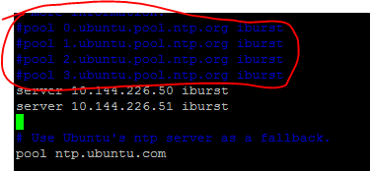

Comment the above 4 lines & add the below two lines

server 10.144.226.50 iburst

server 10.144.226.51 iburst

**Step 3: Enable & Start the ntp service**

# systemctl restart ntp

**Step 4: Check the sync status**

# ntpq -p

# timedatectl set-timezone Asia/Kolkata

# timedatectl